Supervised Machine Learning

Naïve Bayes

Classification algorithm, e.g. predicting malignant cancer from benign. Note there are many ways to classify a single object. For example, a human has two legs but is also a mammal.

There are two main categories of ML Algorithms:

* Generative
* Discriminative



Figure :Visual representation of discriminative and generative ML

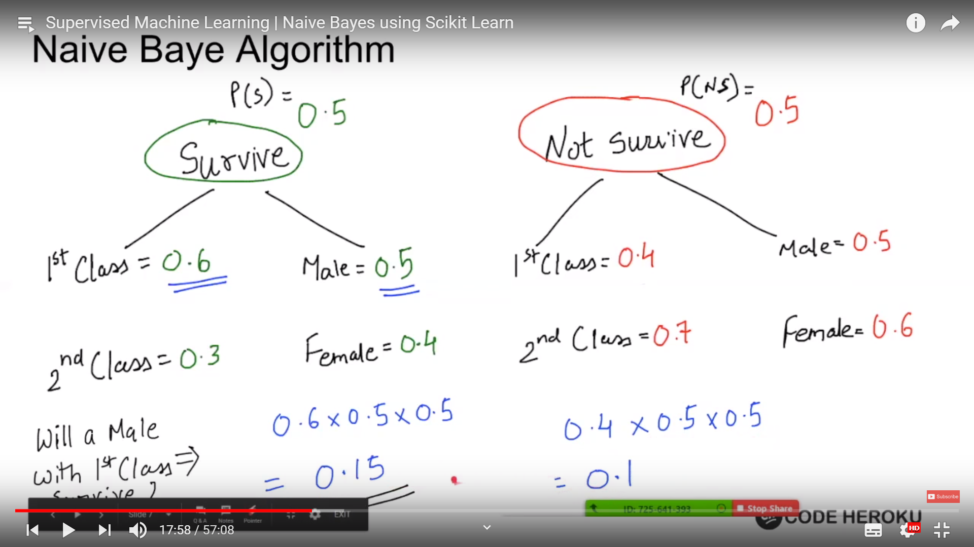

Figure 2: The chances of male first class surviving is greater than not surviving so will likely survive.

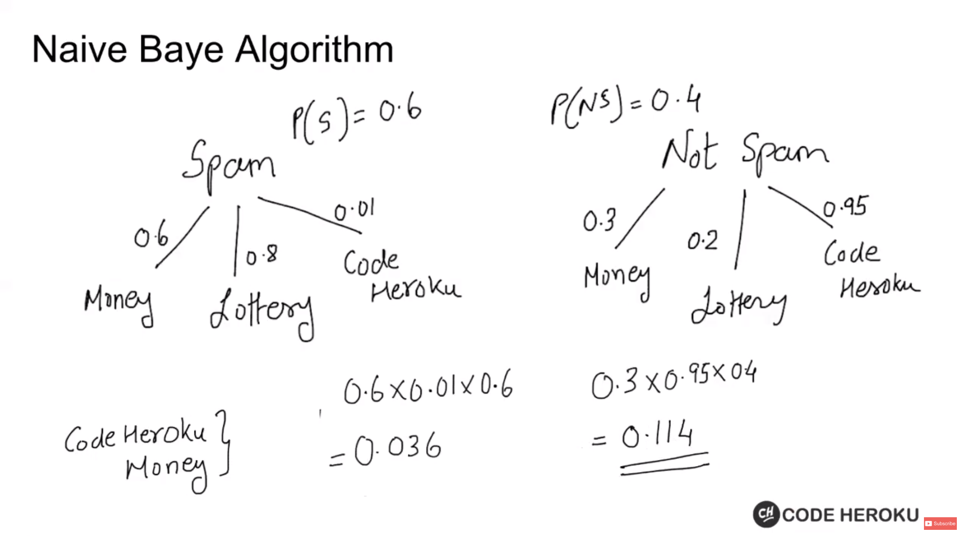

Figure : Simplified version of spam emails.

In figure 3 we are assuming the that the location of occurrence does not matter. Also, e.g. that money and lottery are independent of each other/events.

Thus “Naïve” Bayes, as we assume each feature are independent of each other and that the location of occurrence is independent of each other.

Advantages:

* Simple and easy to implement
* Executes quickly
* Scale for real-time use cases and massive data sets